Create Load Balance in ApiGateWay

- Original config

server.port=8082

app.resourceserver.base-url=http://localhost:8081
app.photoserver.base-url=http://localhost:8090
app.albumserver.base-url=http://localhost:8091

# ===== WebMVC Gateway routes (NOT spring.cloud.gateway.routes) =====

spring.cloud.gateway.server.webmvc.routes[0].id=users-status-check
spring.cloud.gateway.server.webmvc.routes[0].uri=${app.resourceserver.base-url}
spring.cloud.gateway.server.webmvc.routes[0].predicates[0]=Path=/users/**
spring.cloud.gateway.server.webmvc.routes[0].predicates[1]=Method=GET
spring.cloud.gateway.server.webmvc.routes[0].filters[0]=RemoveRequestHeader=Cookie

spring.cloud.gateway.server.webmvc.routes[1].id=photos
spring.cloud.gateway.server.webmvc.routes[1].uri=${app.photoserver.base-url}
spring.cloud.gateway.server.webmvc.routes[1].predicates[0]=Path=/photos/**
spring.cloud.gateway.server.webmvc.routes[1].predicates[1]=Method=GET
spring.cloud.gateway.server.webmvc.routes[1].filters[0]=RemoveRequestHeader=Cookie

spring.cloud.gateway.server.webmvc.routes[2].id=albums
spring.cloud.gateway.server.webmvc.routes[2].uri=${app.albumserver.base-url}
spring.cloud.gateway.server.webmvc.routes[2].predicates[0]=Path=/albums/**
spring.cloud.gateway.server.webmvc.routes[2].predicates[1]=Method=GET
spring.cloud.gateway.server.webmvc.routes[2].filters[0]=RemoveRequestHeader=Cookie

spring.application.name=ApiGateWay
eureka.client.serviceUrl.defaultZone: http://localhost:8010/eureka

- Update load balance : uri=lb://ResourceServer ចឹងក្នុង Spring cloud វាដឹងថាជា lb: load balance ហើយ

server.port=8082

spring.cloud.gateway.server.webmvc.routes[0].id=users-status-check
spring.cloud.gateway.server.webmvc.routes[0].uri=lb://ResourceServer
spring.cloud.gateway.server.webmvc.routes[0].predicates[0]=Path=/users/**
spring.cloud.gateway.server.webmvc.routes[0].predicates[1]=Method=GET
spring.cloud.gateway.server.webmvc.routes[0].filters[0]=RemoveRequestHeader=Cookie

spring.cloud.gateway.server.webmvc.routes[1].id=photos
spring.cloud.gateway.server.webmvc.routes[1].uri=lb://Photos
spring.cloud.gateway.server.webmvc.routes[1].predicates[0]=Path=/photos/**
spring.cloud.gateway.server.webmvc.routes[1].predicates[1]=Method=GET
spring.cloud.gateway.server.webmvc.routes[1].filters[0]=RemoveRequestHeader=Cookie

spring.cloud.gateway.server.webmvc.routes[2].id=albums
spring.cloud.gateway.server.webmvc.routes[2].uri=lb://Albums
spring.cloud.gateway.server.webmvc.routes[2].predicates[0]=Path=/albums/**
spring.cloud.gateway.server.webmvc.routes[2].predicates[1]=Method=GET
spring.cloud.gateway.server.webmvc.routes[2].filters[0]=RemoveRequestHeader=Cookie

spring.application.name=ApiGateWay
eureka.client.serviceUrl.defaultZone: http://localhost:8010/eureka

Testing Postman:

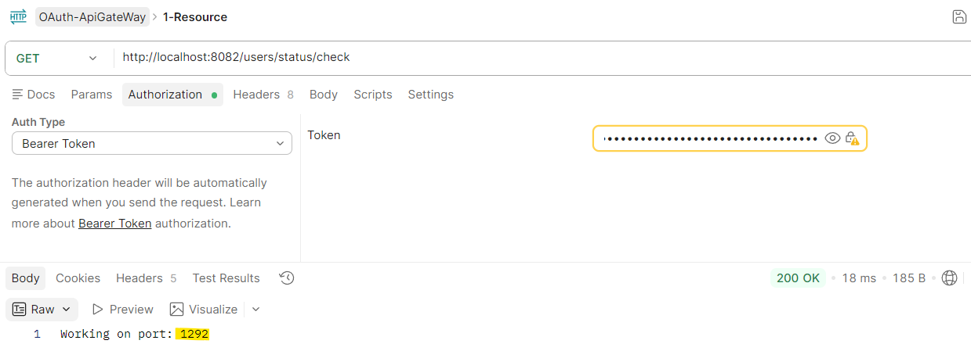

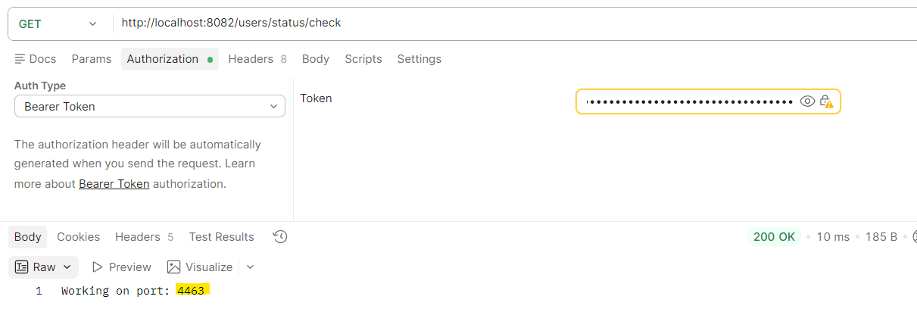

ចឹង ApiGateWay វាចេះធ្វើការហើយដោយ switch service ម្តងម្នាក់
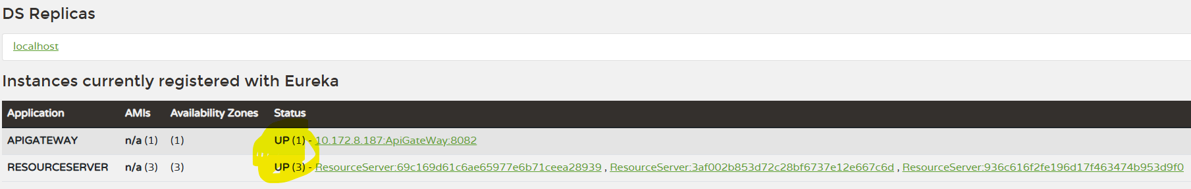

3. Inject the Environment env មកប្រើ
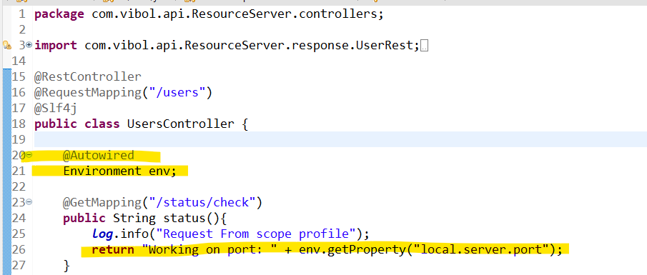

In spring boot we can inject this Environment មកប្រើបាន​

package com.vibol.api.ResourceServer.controllers;

import com.vibol.api.ResourceServer.response.UserRest;
import lombok.extern.slf4j.Slf4j;

import org.springframework.beans.factory.annotation.Autowired;
import org.springframework.core.env.Environment;
import org.springframework.security.access.annotation.Secured;
import org.springframework.security.access.prepost.PostAuthorize;
import org.springframework.security.access.prepost.PreAuthorize;
import org.springframework.security.core.annotation.AuthenticationPrincipal;
import org.springframework.security.oauth2.jwt.Jwt;
import org.springframework.web.bind.annotation.*;

@RestController
@RequestMapping("/users")
@Slf4j
public class UsersController {

@Autowired
Environment env;

@GetMapping("/status/check")
public String status(){
log.info("Request From scope profile");
return "Working on port: " + env.getProperty("local.server.port");
}

// @PreAuthorize("hasAuthority('ROLE_developer') or #id == #jwt.subject")
@PreAuthorize("#id == #jwt.subject")
// @PreAuthorize("hasRole('developer')")
// @Secured("ROLE_developer")
@DeleteMapping(path="/{id}")
public String deletedUser(@PathVariable String id, @AuthenticationPrincipal Jwt jwt){
return "Deleted user with id: " + id + " and JWT subject " + jwt.getSubject();
}

@PostAuthorize("returnObject.userId == #jwt.subject")
@GetMapping(path="/{id}")
public UserRest getUser(@PathVariable String id, @AuthenticationPrincipal Jwt jwt){
return new UserRest("Vibol","long","80373687-a5e1-43d6-bbd8-36d421e760c");
}

}

